Amazon Web Services

**Network Address Translation**

# Network Address Translation

* We can now use Network Address Translation (NAT) Gateway, a highly available AWS-managed service that makes it easy to connect to the Internet from instances within a private subnet in an AWS Virtual Private Cloud (VPC).
* We need to create NAT in the public subnet.

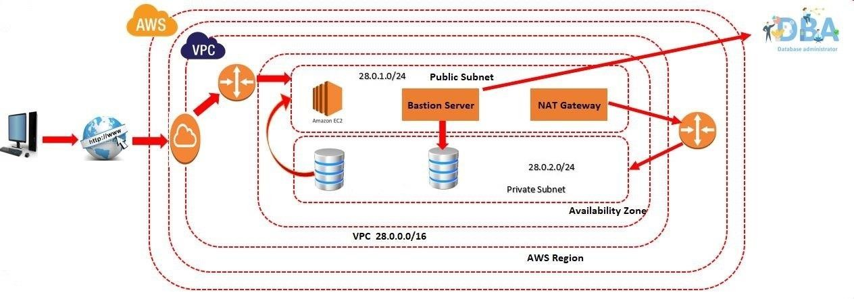

# Network Address Translation

* Click on Nat Gateways
* Click on Create Nat Gateway
* Enter the Name & Select the subnet (Public Subnet)
* Click on Allocate Elastic IP
* Click on Create NAT Gateway

# Network Address Translation

* Go to Route table
* Create a new Route table
* Attach Route table to Private Subnet

Actions

Edit Subnet Associations

* Select private subnet
* Click on Save Associations

# Network Address Translation

* Attach Route table to Nat Gateway

Actions

Edit Routes

* Click on Add route
* Select target as Nat gateway
* Enter Destination as 0.0.0.0/0
* Click on save changes

# Network Address Translation

* Connect Bastion Server
* Switch User sudo su
* Get the SSH Client Details of our Database Server
* Copy the Command & Paste the command in the Putty
* Switch User sudo su
* Command to upgrade MYSQL database yum install mysql -y

# Notes

* It is similar to Static IP. An Elastic IP address is a reserved public IP address that we can assign to NAT Gateway, until we choose to release it. Elastic IP address remains in place through events that normally cause the address to change, such as stopping or restarting the instance. If we stop and start the machine, we want the same public IP, then we create Elastic IP. NAT is a closed box. It does not have any ports concept.
* So, No one can connect to NAT.
* **Why do we need Elastic IP to NAT?**
* If incase NAT is down, entire private subnet will not get internet. Then we need to restart the NAT Gateway, then it acquire new public IP. When NAT acquire new public IP, there could be connection issue. So we need Elastic IP to NAT